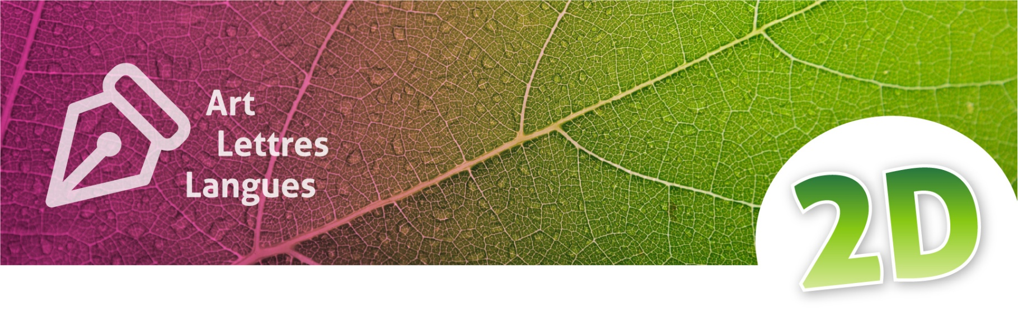
Travaux dirigés

GREENCOMP:
Sustainable Urban Projects and Systemic Thinking
Contexte d’apprentissage
Ce TD, en anglais, explore l’écologie urbaine et la transition écologique à travers la découverte d’un projet réel. Il peut être précédé par des activités de découverte du vocabulaire spécifique lié à la thématique et complété par un TD d’analyse du référentiel Greencomp.
Objectifs disciplinaires
À l’issue de ce TD, les étudiantes et étudiants devront être en mesure de :
- Analyser un texte authentique simplifié sur un projet durable réel ;
- Utiliser du vocabulaire lié à l’écologie urbaine et à la transition écologique ;
- Identifier les dimensions sociales, environnementales et économiques d’un projet ;
- Travailler en collaboration en anglais.
Objectifs extra-disciplinaires
- Expliquer simplement des notions liées à la résilience, la biodiversité et la pensée systémique ;
- Développer son esprit critique à travers des questions ouvertes.

Warm-up discussion (10 min)
In pairs, discuss your views on the two topics below:
- Why are green spaces important?
- Can industrial areas become ecological spaces again?

- Reading activity (20 min)
Read the text individually, then discuss it as a group, using the glossary in Appendix 2.
Use three coloured markers to highlight:
- Environmental actions ;
- Social actions ;
- Climate-related problems.

- Vocabulary activity
Challenge: Explain these three words to the members of your groups in English.
Use very simple sentences and examples from your own town.
- Resilience
- Wetlands
- Biodiversity
- Reading comprehension (15 min)
Answer the three comprehension questions based on the text in Appendix 1
(In your group: Nominate a scribe, write your answers down and present them to the class, as a group)
- What was the original function of the India Basin area?
- Why are wetlands important in this project?
- Why does the text say that sustainable development is complex?
- GreenComp discussion activity (25–30 min)
In small groups, discuss the following two open-ended questions. Prepare your best and longuest sentence as it will be shared with the group :
- What skills do future professionals need to help create more sustainable cities and organisations?
- What is systemic thinking (in environmental projects)? Why is it so important when dealing with environmental questions?
Annexe 1 : India Basin Waterfront Park – A Sustainable Urban Project - Synthèse réalisée par l’auteure à partir des informations disponibles sur le site du projet https://ibwaterfrontpark.com/projectdesign

India Basin Waterfront Park – A Sustainable Urban Project
In many cities around the world, old industrial areas are being transformed into greener and more sustainable spaces. One example is the India Basin Waterfront Park project in San Francisco. The project aims to transform a polluted industrial waterfront into a public park that combines nature, climate resilience and community spaces.
The area was previously affected by industrial activities and pollution. Today, the project focuses on ecological restoration and environmental protection. Wetlands and natural habitats are being restored in order to improve biodiversity and help protect the area against rising sea levels and climate change.
The project is not only about the environment. It also includes social and community objectives. The designers want local residents to have better access to green spaces, walking areas and recreational activities. Public participation and collaboration with local communities are important parts of the project.
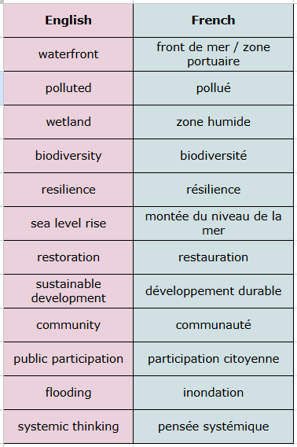
Another important aspect is resilience. The park is designed to adapt to future environmental challenges, especially flooding and sea level rise. Instead of using only technical solutions, the project tries to combine ecological, social and urban approaches.
This project shows that sustainable development is often complex. Environmental decisions can involve economic costs, political choices and social consequences. It also demonstrates how future professionals can contribute to more sustainable cities and organisations through systemic thinking and collaboration.
Annexe 2 : Mini Vocabulary Sheet

Ce TD a été mutualisé dans le cadre d'un partenariat entre l’Université de Bordeaux et la Fondation UVED pour la déclinaison disciplinaire de l'enseignement des enjeux de transition écologique et sociétale (TEDS).

Il est mis à disposition selon les termes de la Licence Creative Commons - 4.0 International : Attribution - Pas d’Utilisation Commerciale - Partage dans les Mêmes Conditions
Pour la formation continue ou professionnelle, les modalités d’usage sont à déterminer avec UVED et doivent faire l’objet d’un contrat définissant les conditions d’usage et de commercialisation. Contact : contact@fondation-uved.fr
Première édition : juin 2026

